| Course Name | ITD 2343 – Object Oriented Programming with C# |
| --- | --- |
| Instructor | Mark L. Pranger |
| Student Name | <Ezequiel Barrientos> |
| Due date | <11/7/25> |
| Grade | <grade earned here> |
| Grading Comments | <instructor comments here> |

Test 1 Valid Input:

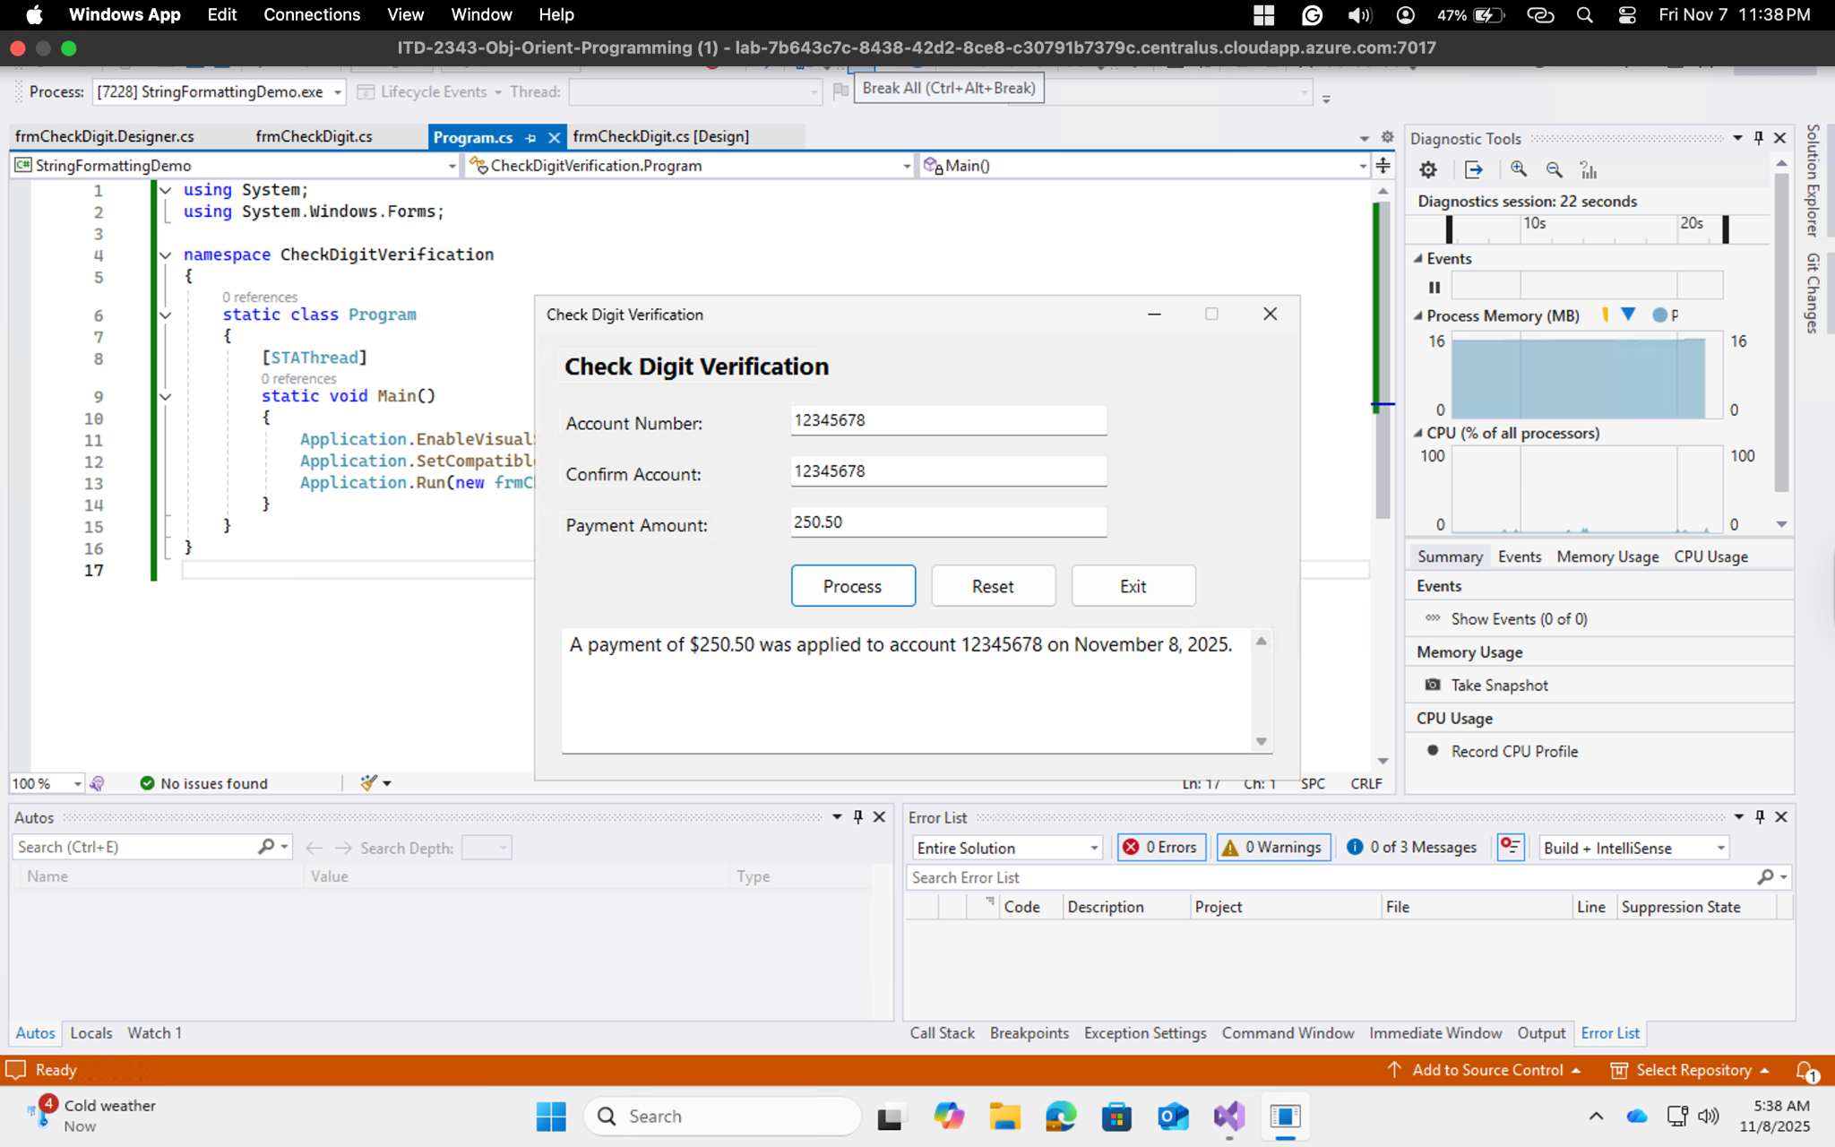

Test 2: Error Account Too Short

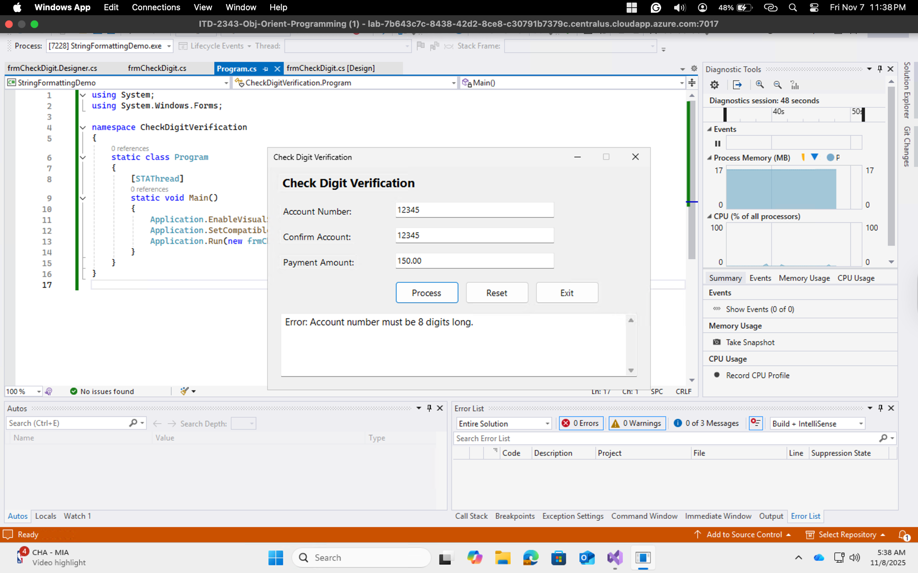

Test 3: Error Account Has Letters

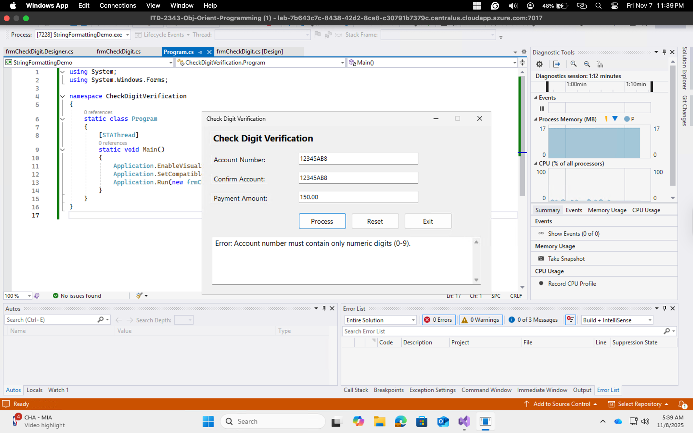

Test 4: Error Account Numbers Don't Match

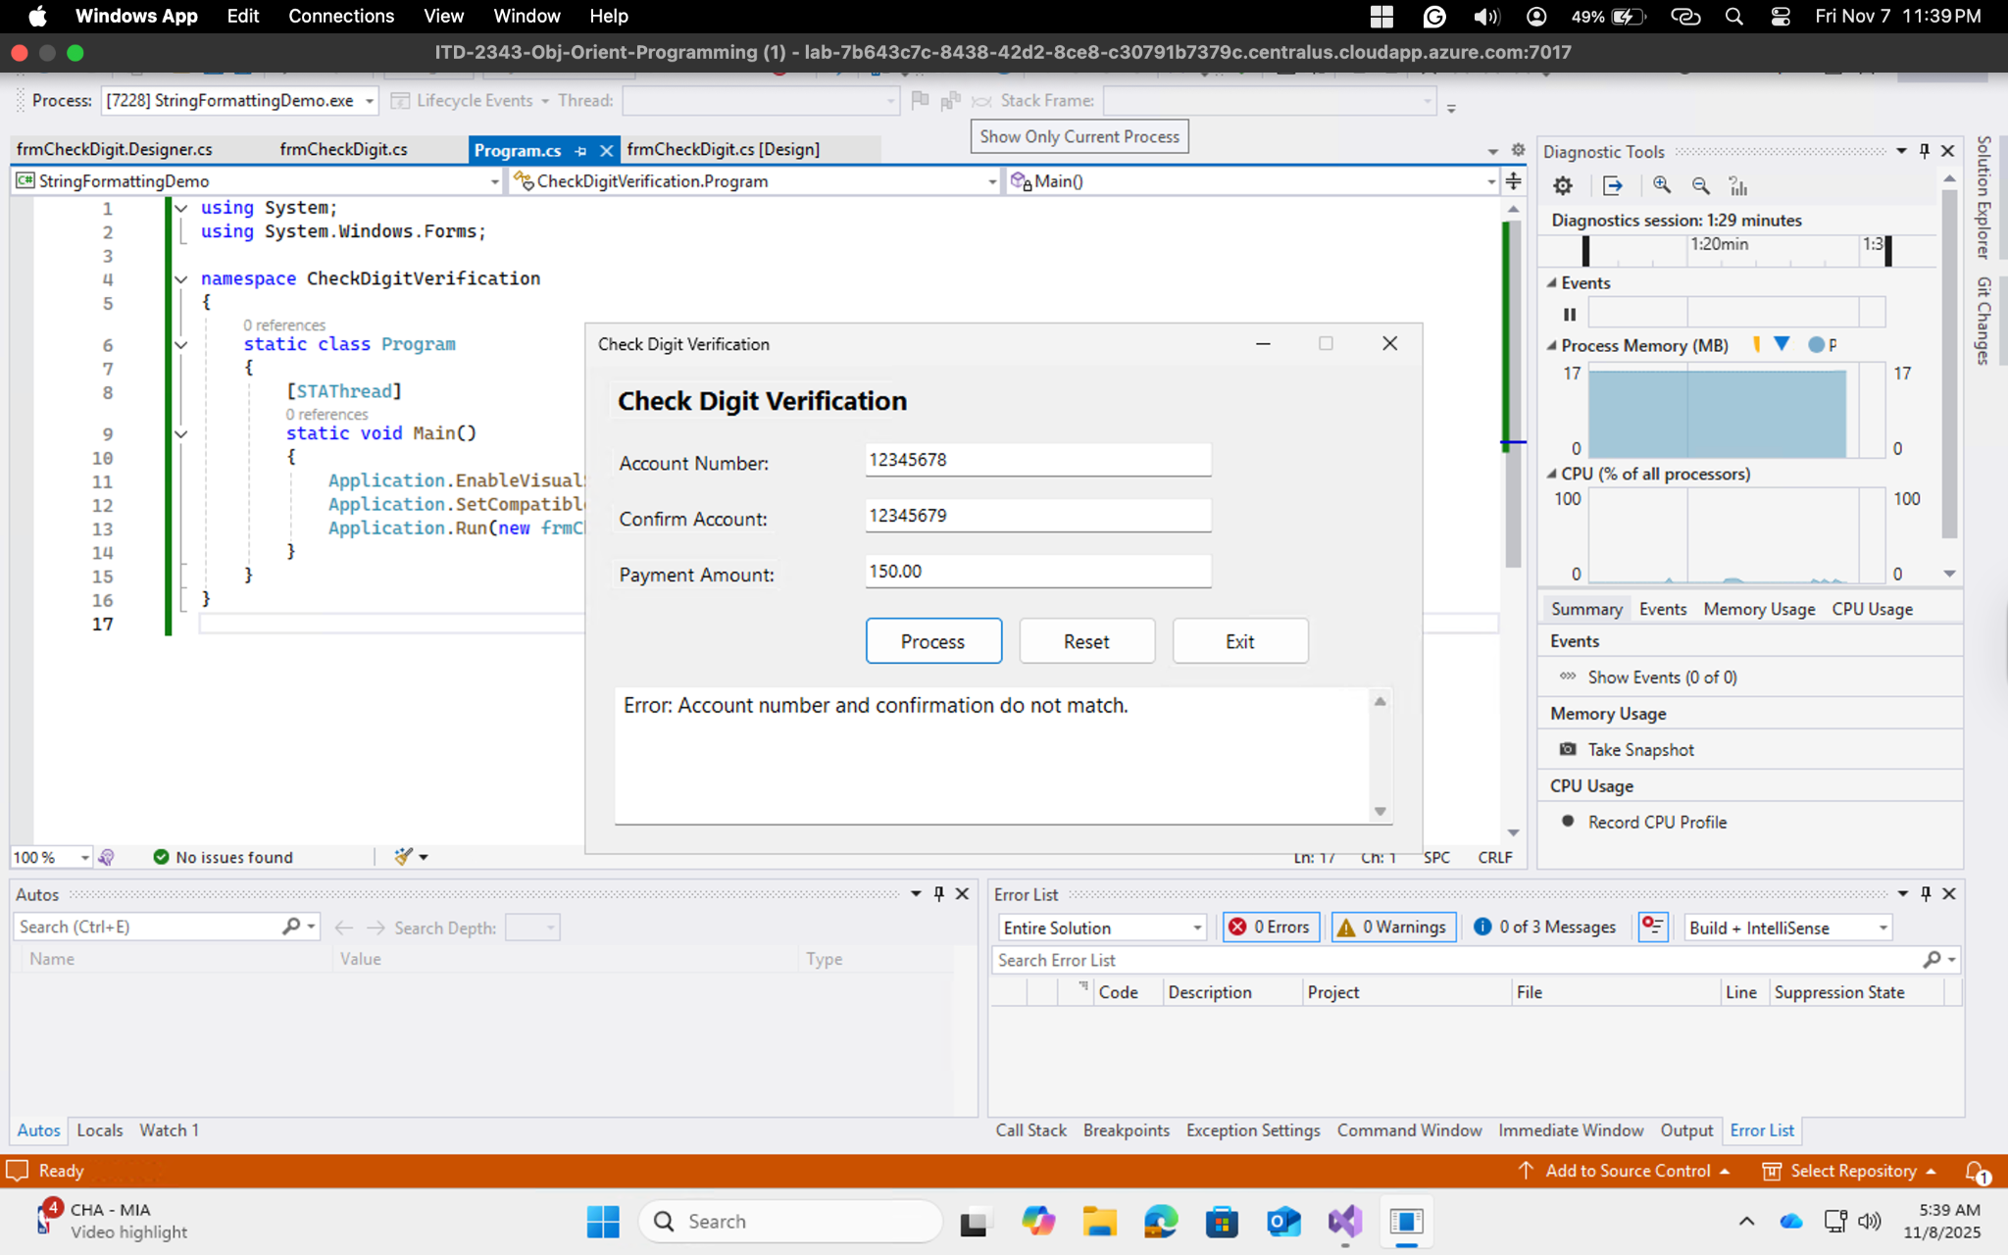

Test 5: Invalid Payment Amount

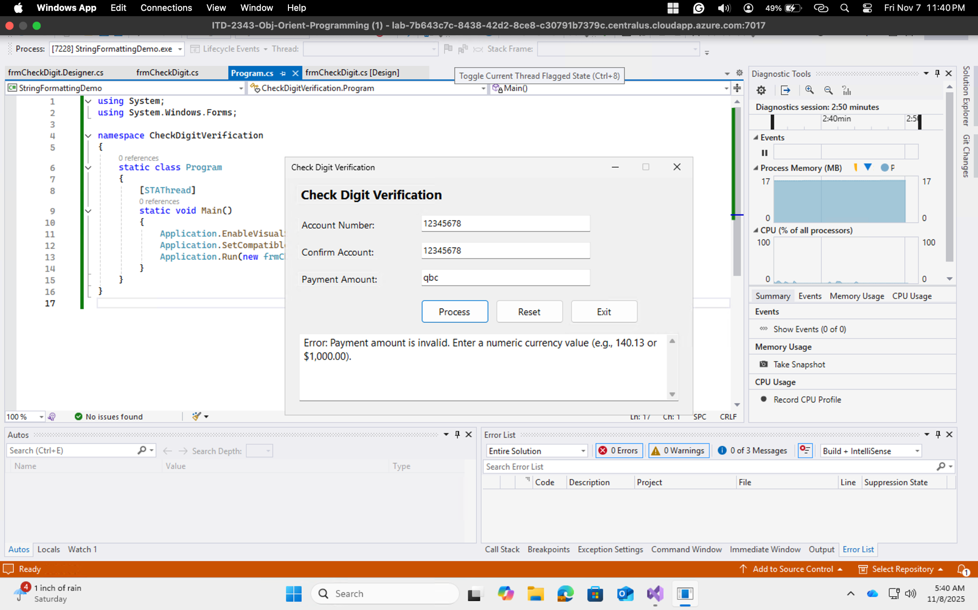

Test 6: Reset Button

